**DEVELOPMENT OF AN IOT INTEGRATED TRICYCLE BOOKING PLATFORM IN WEB AND MOBILE**

_______________________________

A Capstone Project Presented to the Faculty of the

College of Information and Computing Sciences

CAGAYAN STATE UNIVERSITY

Gonzaga, Cagayan

_______________________________

In Partial Fulfilment of the Requirements for the Degree

**BACHELOR OF SCIENCE IN INFORMATION TECHNOLOGY**

**______________________________**

**CARRERA, ALTHEA A.**

**DUTDUT, MARY GRACE V.**

**LOS BAÑOS, JASMIN KATE A.**

**VENTURA, REMY DIANNE I.**

[MONTH] [YEAR]

**APPROVAL SHEET**

This Capstone Project entitled **Development of an IoT Integrated Tricycle Booking Platform in Web and Mobile**, prepared and submitted by Althea A. Carrera, Mary Grace V. Dutdut, Jasmin Kate A. Los Baños, and Remy Dianne I. Venturain partial fulfillment of the requirements for the degree Bachelor of Science in Information Technology (BSIT), is hereby recommended for oral examination.

|  |  |
| --- | --- |
| **__________________**  Date | **__________________________**  *English Critic* |
|  |  |
| **__________________**  Date | **_________________________**  *Adviser* |

Approved by the panel on Oral Examination with a grade of _____________.

|  |  |
| --- | --- |
| **__________________________**  *Member* | **__________________________**  *Member* |
|  |  |

**__________________________**

*Chairperson*

Accepted in partial fulfillment of the requirements for the degree Bachelor of Science in Information Technology (BSIT).

**VERDICT L. GONZALES, PhD, DIT**

*Capstone Project In-charge*

**CLYDEN CHARL B. ALIBANIA, PhD**

*College Dean*

**FROILAN A. PACRIS, JR., PhD**

*Campus Executive Officer*

**dedication**

**Top of Form**

**ABSTRACT**

|  |  |
| --- | --- |
| **TITLE :** | DEVELOPMENT OF AN IOT INTEGRATED TRICYCLE BOOKING PLATFORM IN WEB AND MOBILE |
| **RESEARCHER :** | CARRERA, ALTHEA A.  DUTDUT, MARY GRACE V.  LOS BAÑOS, JASMIN KATE A.  VENTURA, REMY DIANNE I. |
| **DEGREE :** | BACHELOR OF SCIENCE IN INFORMATION TECHNOLOGY (BSIT) |
| **INSTITUTION :** | CAGAYAN STATE UNIVERSITY |
| **YEAR :** | 2025 |
| **ADVISER :** | **__________________________**  Assistant Professor IV |
|  |  |

**TABLE OF CONTENTS**

**Title Page #**

|  |  |
| --- | --- |
| **PRELIMINARIES** |  |
| Title Page…………………………………………………………………… | i |
| Approval Sheet……………………………………………………………… | ii |
| Acknowledgement………………………………………………………... | iii |
| Dedication ………………………………………………………….. | vi |
| Abstract………………………………………………………… | vii |
| Table of Contents…………………………………………………………… | ix |
| List of Tables……………………………………………………………….. | xi |
| List of Figures………………………………………………………………. | xii |
|  |  |
| **CHAPTER I – INTRODUCTION** |  |
| Project Context……………………………………………………………… | 1 |
| Purpose and Description……………………………………………………. | 2 |
| Conceptual Framework……………………………………………………... | 3 |
| Objectives…………………………………………………………………… | 4 |
| Scope and Delimitations……………………………………………………. | 5 |
| Significance of the Study…………………………………………………… | 6 |
| Definition of Terms…………………………………………………………. | 8 |
|  |  |
| **CHAPTER II –REVIEW OF RELATED LITERATURE** |  |
| Foreign Literature…………………………………….. | 10 |
| Local Literature |  |
| Synthesis |  |
| Similarities |  |
| Differences |  |
| **CHAPTER III – TECHNICAL BACKGROUND** |  |
| System Requirements ……………………………………………………… | 20 |
| Hardware………………………………………………………… | 20 |
| Software……………………………………………………………. | 23 |
| Peopleware |  |
| System Architecture |  |
| **CHAPTER IV – RESEARCH METHODOLOGY** |  |
| Research Design…………………………………………………………….. | 29 |
| Instrumentation……………………………………………………………... | 29 |
| Data Gathering Procedure…………………………………………………... | 30 |
| Participants of the Study……………………………………………………. | 30 |
| Data Analysis |  |
| Likert Scale |  |
| Requirements Analysis……………………………………………………... | 36 |
| Requirements Documentation………………………………………………. | 39 |
| Functional Requirements |  |
| Flowchart |  |
| Context Level Diagram |  |
| Data Flow Diagram |  |
| Design of Software/Systems/Product/Processes |  |
| Hierarchical Input Process Output (HIPO) |  |
| Data Requirements/Description/Dictionary |  |
| Entity Relationship Diagram |  |
| Users’ View |  |
| 1. Data Environment |  |
| 1. Data Entry |  |
| 1. Data Description |  |
| Development and Testing |  |
| Implementation Plan………………………………………………………... | 42 |
| **CHAPTER V – RESULTS AND DISCUSSION** |  |
| Results and Discussion……………………………………………………… | 43 |
|  |  |
| **CHAPTER VI – SUMMARY, CONCLUSION, AND RECOMMENDATIONS** |  |
| Summary……………………………………………………………………. | 68 |
| Conclusion………………………………………………………………….. | 68 |
| Recommendation…………………………………………………………… | 69 |
|  |  |
| **BIBLIOGRAPHY (APA 7TH EDITION)**……………………………………. | 71 |
| **APPENDICES**……………………………………………………………………... | 75 |
| 1. Source Code |  |
| 1. Completion Form |  |
| 1. Sample Input/Output/Reports |  |
| 1. User’s Guide |  |
| 1. Communication Letters |  |
| 1. Sample Generated Outputs |  |
| 1. Pictures of data gathering, investigation done (floor plan, building, layout, etc.), system development sessions. |  |
| **CURRICULUM VITAE**…………………………………………………………... | 121 |

**LIST OF TABLES**

|  |  |  |
| --- | --- | --- |
| Table No. | Title | Page No. |
|  | The Current System……………………………………….. | 21 |
|  | The Current System Users………………………………. | 21 |
|  | Hardware……………………………………………… | 23 |
|  | Software………………………………………………… | 24 |
|  | Peopleware……………………………………………… | 24 |

**LIST OF FIGURES**

|  |  |  |
| --- | --- | --- |
| FigureNo. | Title | Page No. |
|  | Conceptual Framework……………………………………… | 3 |
|  | Current System Architecture………………………………… | 22 |
|  | System Architecture……………………………………….. | 28 |
|  | Rapid Application Development (RAD)…………………… | 33 |
|  | Use Case Diagram………………………………………… | 40 |

**Chapter 1**

**INTRODUCTION**

**PROJECT CONTEXT**

Technology, a ground-breaking innovation that transformed lives in many aspects, have provided solutions to problems in our day-to-day life. Its ease of use and usefulness is what drives user acceptance which is stated in the Technology Acceptance Model (Davis, 1989). And user acceptance is what pushes industries to embrace and integrated new technologies into information systems which further revolutionizes these systems.

Uber, being first of its kind, became a global revolution in the field of transportation services. Its creation was fueled by the frustrations of two computer engineers who had difficult time looking for a taxi in the streets of Paris which was a prominent challenge in the industry at the time—the accessibility of transportation. The birth of Uber set the path for more ride-hailing applications to emerge with the aim of solving more challenges faced by the industry. And these applications gained the attention of users, particularly commuters, as they provide a flexible, convenience, and accessible platform to access transportation (Feng et al., 2021).

Cagayan State University-Gonzaga and its expansive grounds have posed a challenged to the student. With the tricycle terminal located outside of the campus, circumstances like extreme weather conditions as well as heavy bags that students carry causes inconvenience and difficulties. At the same time, it also presents opportunities, a high demand for the availability of transportation inside the campus. The challenges as well as the opportunities presented inspires the development of a system that aims to address the issues.

This project proposes an IoT integrated system called CSUTrike. This system allows users to book available tricycles at the terminal and be picked up at their location inside the campus. The development of this project aims to provide a reliable, efficient, accessible, and convenient tricycle booking platform for the Cagayan State University-Gonzaga community.

**Purpose and Description**

The challenges and opportunities mentioned above are the foundation for ther development of CSUTrike, an IoT integrated tricycle booking platform. The primary users of the system will be the students of Cagayan State University-Gonzaga, tricycle drivers of Flourishing, and a designated administrator. The system will offer a platform for these users wherein features for each will be unique, user-friendly, and will have appropriate functionality that aligns with what should be done by the users.

The application that will cater the students will be accessible in the web and via mobile app to ensure compatibility across different devices. Furthermore, the following features will be integrated on their side: book or cancel rides unless the driver confirmed their bookings, edit profile, and view current booking details as well as previous ones. On the driver side, an RFID scanner will be used to scan their fobs, serving as their login port to their system. And by logging in, they will be marked active and available for booking. A web application will be developed for them wherein they can view their bookings and decide whether to confirm or decline. The admin, on the other hand, has the privilege to oversee the system by their web application. They have the ability to add, delete, or update driver’s information, accept or reject requests from users for account creation or delete users, and view current and previous booking transactions and download them.

Real-time update will be applied in the system to ensure that the data being sent is retrieve on time, ensuring the integrity of the data. This development aims to address the issues mentioned earlier and to provide a convenient booking platform that caters to the Cagayan State University-Gonzaga community.

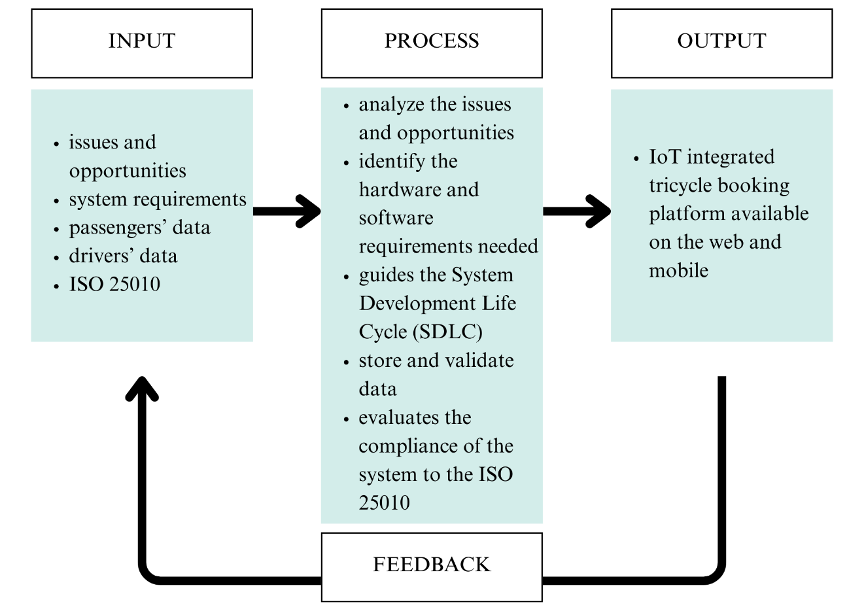**CONCEPTUAL FRAMEWORK**

***Figure 1: Conceptual Framework for the Development of CSUTrike, an IoT Integrated Tricycle Booking Platform***

Figure 1 shows the input-process-output (IPO) model, a widely used framework that describes how the input of the system is processed to produce an output. The figure above illustrates the IPO model applied in the development of CSUTrike, an IoT integrated tricycle booking platform.

**OBJECTIVES**

This project aims to design and develop an IoT integrated tricycle booking platform available in the web and mobile, catering the community of Cagayan State University.

It also aims to:

1. Analyze the issues and opportunities presented by the challenge in the accessibility of transportation service inside the campus
2. Determine the requirements needed for the development of the system
3. Evaluate the compliance of the system to the ISO 25010

**SCOPE AND DELIMITATIONS**

The project aims to develop an IoT-integrated tricycle booking platform for web and mobile to improve the transportation services at Cagayan State University – Gonzaga by enhancing convenience and accessibility. The system allows students to book tricycle rides from specific locations within the campus. IoT technology for driver verification and real-time booking operation is applied to improve the overall convenience it will provide to the users. The system is designed for use by students and tricycle drivers.

The system covers the following:

* User Access and Role Management: The system will have different interfaces for students and tricycle drivers. These interfaces allow users to register and book rides while drivers can either confirm or decline their bookings.
* IoT Integration: The system will use RFID technology for driver authentication and Wi-Fi module for connectivity.
* Booking and Tracking: The system allows students to book tricycle rides from specific places in the campus and track available drivers real-time.
* Automated Report Generation: The system generates tricycle booking reports to track ride transactions and improve the efficiency of the system.

Limitations:

* Campus Exclusive Implementation: The system is specifically designed for use within Cagayan State University – Gonzaga.
* Student Commuters Exclusive: The system is specifically designed and developed only for student commuters.
* Limited IoT Functionality: The integration of IoT is primarily for driver authentication, and system connectivity but does not include advanced GPS tracking.
* Platform Specific Accessibility: Students will only have access to the system via mobile and web applications, while tricycle drivers will use desktop application.
* Internet Dependence: The system requires an internet connection for real-time functionality.

**SIGNIFICANCE OF THE STUDY**

This project is significant as it introduces an IoT-integrated tricycle booking platform that is designed to make commuting within Cagayan State University – Gonzaga easier, faster, and more convenient. By combining real-time booking, automated tracking of available drivers, and IoT-based authentication, the system aims to simplify the transportation process for students and tricycle drivers. The following will benefit from this project:

* For Educational Institutions: This system helps improves campus transportation by providing a reliable and technology-driven transportation solution.
* For Students: The system will provide a user-friendly interface where they can book tricycles with just few taps on their phone instead of walking to the terminal, saving time and makes commuting around the campus much easier.
* For Tricycle Drivers: The system gives drivers a steady flow of passengers from inside the campus, helping them to earn more. More than just increasing their income, it also introduces them to a modern, digital way of managing bookings. They will learn to handle ride requests, use automated booking features, and interact with IoT-based technology, making their work more efficient and helps them adapt to the growing use of technology in transportation services.
* For Future Researchers: This study serves as foundation for future advancements in campus transportation, IoT integration, and smart mobility solutions.

**DEFINITION OF TERMS**

The following terms are used in the project and defined to ensure clarity and consistency in interpretation.

1. **Authentication** – This is the process of verifying the identity of the users to secure the access of the system.
2. **Automated Report Generation** – This is the automatic creation of reports without human intervention.
3. **Booking Platform** – This is a website on an app that lets people reserve services online.
4. **Internet of Things (IoT)** – These are referred to as “smart objects” embedded with sensors, software, and network connectivity, allowing the collection and exchange of data over different devices and systems over the internet.
5. **ISO 25010** – It provides a set of guidelines to evaluate the quality of the software.
6. **Radio Frequency Identification (RFID)** – This is a technology integrated in systems that uses radio waves to identify and track objects.
7. **Real-time Update** – This is an information that gets refreshed and shown instantly as it happens.
8. **Ride-hailing Application –** This is an application that connects users and drivers, allowing users to book rides with drivers.
9. **Web Application** – This a software program that can be accessed and use through a web browser.
10. **Wi-Fi Module** – This is a small device that allows gadgets to connect to the internet or network.

**Chapter 2**

**REVIEW OF RELATED LITERATURE**

This section of the project provides a review on the following topics, aiming to analyze and understand ride hailing applications and its impact. This review will provide a foundation for the development of CSUTrike, a ride hailing application that caters Cagayan State University – Gonzaga community.

**RIDE-HAILING APPLICATIONS**

The birth of ride-hailing applications began in 2009 with Uber’s launch. The creation of Uber leads to the rapid increase of more ride-hailing platforms, providing a more convenient and efficient way of transportation services (Feng et al., 2021). Ride-hailing is a service that serves as a bridge, connecting the drivers and commuters for booking rides (Wen et al., 2024). The growth of these applications is driven by the continuous advancement of technology, shifting the traditional transportation services to online for convenience and accessibility (Dua and Sheldon, 2024). The infusion of modern technology involving GPS tracking, cashless payments, and ride matching algorithms transformed the industry (Acheampong, 2021). This advancement revolutionized ride-hailing applications by integrating other technologies to further improve the overall convenience it provides to the commuters. Studies have highlighted the current technologies and trends adapted to enhance ride-hailing applications.

Machine learning is one of the trends that had been adapted and its integration improves the decision-making process in the application (Wen et al., 2024; Putra et al., 2024). Putra et al. (2024) broadens the trends adapted by citing and emphasizing the use of more integrated technologies like the use of data analytics for analysis, Global Positioning System (GPS) for tracking, and digital payment for an efficient mode for payment that shapes the future of these applications. On top of that, ride-hailing applications also use data analytics in route optimization plans and demand prediction for enhanced efficiency of urban transport networks. They are also growing into emerging markets while incorporating local options for transport needs, including motorcycles and tricycles as ride-hail options (Olayode et al., 2023).

Both Tirachini (2020) and Dias et al. (2019) highlighted how ride-hailing applications enhance accessibility and inclusivity by providing a platform for individuals without cars or those who do not prefer to driver as well as people with physical or cognitive limitations. Ofori et al. (2021) also notes that a certain determinants of post-adoption behavior for ride-hailing users are important. Basically, perceived customer value influences the continued use of the service. They also pinpointed factors such as affordability, ease of access, and safety as core determinants of user satisfaction (Ofori et al., 2021).

Based on the studies mentioned, it is clear that ride-hailing applications change the course for transportation services. This is a smart innovation that solved one of the challenges faced in the industry by providing a user-friendly platform connecting drivers and passengers. Through this review, an analysis on how ride-hailing applications works and the requirements and features to be considered is created, becoming the foundation in the development of CampusTrike.

**INTERNET OF THINGS (IOT)**

The turning point of technology to be more transformative is its integration with physical devices through the internet, allowing an autonomous collection of data and interconnecting the digital and physical worlds (Dubey & Yadav, 2024). This integration is known as Internet of Things (IoT), a smart innovation that has impacted various sector in many ways, enhancing efficiency, connectivity, data processing, and decision-making (Dubey & Yadav, 2024; Adhicandra et al., 2024).

Features like real-time tracking through GPS, vehicle communication, data analytics and predictive maintenance are essential for ride-hailing applications, a vital role in enhancing efficiency and improving safety (Mohamed et al., 2019; Peace 2024; Supian et al., 2024). Through its integration, monitoring the vehicle, user behavior and trends, and vehicle communications becomes possible, improving route planning and safety as well as reducing downtime (Gambella et al., 2019; Joy et al., 2018; Anagnostopoulou et al., 2020).

In conclusion, the integration of IoT in ride-hailing applications has led to a significant advancement in modern urban mobility solutions, by offering features that enhances user experience, helps in management, and support data-driven decision-making, impacting the effectiveness and reliability of these services.

**RADIO FREQUENCY IDENTIFICATION (RFID) TECHNOLOGY**

Radio Frequency Identification (RFID) is a technology that uses radio waves to identify and tract objects or people wirelessly using RFID fobs. Its application has been extensive and various industries embraced this technology due to its capabilities that enhance efficiency and convenience, strengthening the industries with its integration. Compared to QR codes and barcodes, RFID is in advantage in many aspects including its ability to read tags simultaneously, longer reading range, and automation capabilities.

In transportation services, this technology helps in streamlining the management of vehicles and improve logistics. Laha and Putatunda (2018) highlights how real-time location tracking using GPS effectively reduces idle time and enhances ride responsiveness, directly influencing user satisfaction. Ghani et al. (2021) supports this by emphasizing how RFID facilitates tracking efficiently.

The integration of this technology influences user satisfaction and service quality (Do et al., 2019; Oviedo et al., 2023). RFID’s integration transforms transportation services, enhancing efficiency, and improving customer satisfaction.

**USER TRUST AND ADOPTION OF RIDE-HAILING APPLICATION**

User trust and adoption are essential aspects in ride-hailing applications. These aspects are influenced by user demographics, ease of use, usefulness, and trust-building mechanisms.

Trust is a vital part of user acceptance and there are a significant number of studies that supports this. Akbari et al. (2020) highlights how building trust in ride-hailing applications mitigate risks and increases adoption rates. Shao and Yin (2019) supports this notion by stating that mechanisms like payment security and driver certification enhances trust, increasing user engagement in ride-hailing applications. Wu and Neill (2020) further notes that these applications help in developing user trust and influence user behavior positively.

Studies highlights how demographics are likely to affect adoption of ride-hailing services (Mitra et al., 2019; Lim & Fernandez, 2022). Additionally, Almunawar et al. (2020) highlights the role of social influences in adoption which enhances the acceptance rate of these services. The perception of safety plays an important role in user trust wherein Alonso-González et al. (2020) suggested that previous positive experiences influences user engagement, trust, and adoption.

The Technology Acceptance Model states that the key to adoption and acceptance is based on how easy to use a technology and its usefulness. Based on the papers that highlight user trust and adoption of ride-hailing applications, it is very important to prioritize the safety and the overall convenience of the users to enhance user engagement and satisfaction. Through this review, the trust-building mechanism to be adopted in the development of CSUTrike is determined with the aim of a gaining a high user trust and adoption.

**IMPACT OF RIDE-HAILING APPLICATIONS**

The birth of ride-hailing applications led to a significant transportation, positively impacting the transportation services. It impacted the economic, social, environmental, and technological aspect of life.

Olayode et al. (2023) highlights how these platforms not only impacted passengers but drivers as well. With these applications, an opportunity is given to more drivers to gain income and job. Additionally, it became the solution with one of the challenges faced in the industry—the accessibility of transportation. There are significant number of studies supports this by stating how ride-hailing services enhances transportation accessibility both in urban and rural areas, providing an equitable mobility solution (Zou et al., 2023; Cats at al., 2022; Zhong et al., 2024; Etuk et al., 2022).

Ride-hailing application is also tied to the environment sustainability. Gehrke et al. (2019) notes that these services potentially reduce reliance on private car ownership, leading to a lower emission. And its continuous growth contributes to the smart cities and sustainable transportation system of tomorrow (Sheldon and Dua, 2024).

In conclusion, ride-hailing applications redefine the transportation services, offering a flexible solution to modern transportation challenges.

**Chapter 3**

**TECHNICAL BACKGROUND**

Ride-hailing applications are applications that connects the users and drivers, allowing users to book rides using their phone and notify the drivers of the booking details. These applications became a ground-breaking innovation in the field of transportation services, providing efficiency and convenience. Uber, founded in 2009, popularized these applications which was soon adopted by many companies worldwide, increasing the demand in ride-hailing applications.

The existing transportation system at Cagayan State University-Gonzaga presents a significant challenge for students, requiring a long walk between the gate, terminal, and designated buildings within each college. This lengthy road can be inconvenient and time-consuming.

With the mentioned challenges that became the foundation of this project, a user-friendly IoT integrated tricycle booking system will be created with the aim of solving the challenges faced by student commuters at Cagayan State University-Gonzaga, providing a convenient and efficient mode of transportation service within the campus.

**THE CURRENT SYSTEM**

There is currently no system for booking tricycle at Cagayan State University Gonzaga. Students have to physically go to the terminal. This can be hassle during summer time, rainy season and especially to those students who carry heavy stuffs. Tricycle drivers, on other hand, typically wait for passengers at designated terminal.

|  |  |
| --- | --- |
| **ASPECT** | **DESCRIPTION** |
| Manually walking to the tricycle terminal outside the campus | The passengers manually walk to the tricycle terminal outside the campus to catch a ride. This is a time-consuming process that causes inconvenience especially under circumstances like extreme weather conditions. |

***Table 1: The Current System***

**THE CURRENT SYSTEM USER**

The key users of the current system are as follows:

|  |  |
| --- | --- |
| **ASPECT** | **ROLE** |
| Passengers (Students) | The primary user who needs transportation and rides the tricycle. |
| Tricycle Drivers | Waits for passengers at the terminal. |

***Table 2: The Current System User***

**SYSTEM REQUIREMENTS**

This section defines the system requirements needed for CSUTrike to function smoothly and efficiently.

|  |  |  |
| --- | --- | --- |
| **HARDWARE** | **REQUIREMENTS** | **PURPOSE** |
| Smartphone | Android 8.0/iOS 12+, 2GB+ RAM, 100MB free space | For passenger usage (mobile app access) |
| Computer/Laptop | Windows 10+/macOS 10.12, 4GB RAM | Used by drivers for booking display and by the admin for system management |
| Arduino Board | Arduino Uno | For RFID-based driver login system |
| RFID Reader Module | MFRC522/RC522 module | Scans RFID driver cards for system login |
| RFID Fobs | 13.56 MHZ MIFARE cards | For driver identification |
| NodeMCU ESP8266 | Wi-Fi-enabled microcontroller | Connecting the login system of the drivers to the server |

***Table 3: CSUTrike Hardware Requirements***

|  |  |  |
| --- | --- | --- |
| **SOFTWARE** | **REQUIREMENTS** | **PURPOSE** |
| Web browsers | * Google Chrome * Mozilla Firefox * Microsoft Edge | Used by passengers for website booking, by drivers for booking details, and by admin for system management |
| Programming Languages | * .NET MAUI (Mobile application) * PHP and JavaScript (Backend for web) * HTML and CSS (Frontend for web) * C++ (Arduino embedded system) | Core languages used for the development of the system |
| Database Management System (DBMS) | * MySQL | Stores and organizes data and records |

***Table 4: CSUTrike Software Requirements***

|  |  |  |
| --- | --- | --- |
| **ROLE** | **RESPONSIBILITIES** | **USERS** |
| Passengers | Use the mobile app and website to book rides | Students |
| Drivers | Accept/decline bookings, and provide transportation services | Registered tricycle drivers in the system |
| System Administrator | Monitors and maintains the system | Designated admin |
| Developers | Develop, test, and maintain the system during the capstone project | Capstone project team |

***Table 3: CSUTrike Peopleware Requirements***

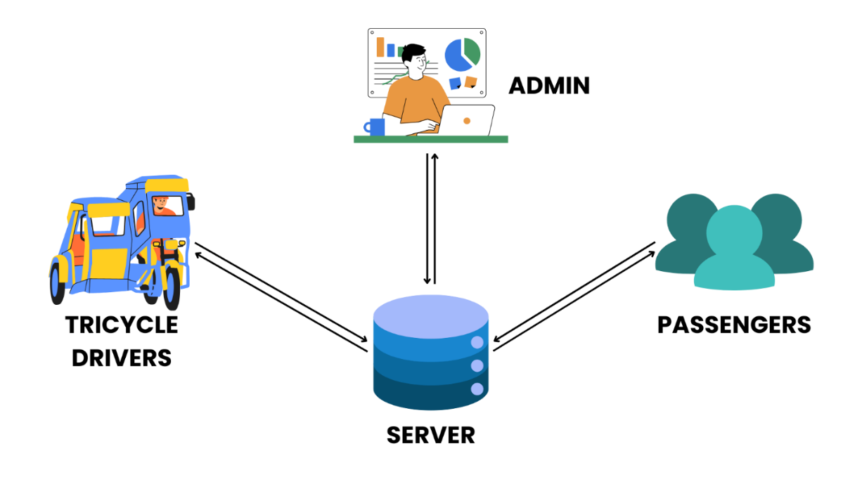**SYSTEM ARCHITECTURE**

***Figure 1: CSUTrike System Architecture***

Figure 1 illustrates the architecture of CSUTrike, providing an understanding on how the components interact in the system. It consists of three user groups: passengers, drivers, and the admin. These users are connected with each other through the server. During the development, a local server is used but an online server is encouraged for future implementation.

The flow of the transaction within the system starts with the driver assuming that they had already been added by the admin. Using their RFID fobs, they will login to the system and their data will be stored in the server, making it accessible for both the passengers and admin to retrieve the currently active and available drivers. And through the server, the passengers will be able to book rides. Their booking details will be stored in the server which will be retrieved in the driver and admin side.

And as shown in the figure, the admin will also be interacting with the server, pulling booking data from the server for generating reports and interfacing the system by with functions like adding new driver.

**Chapter 4**

**RESEARCH METHODOLOGY**

This section outlines the research methodology of the project. It provides an explanation of its design, sampling methods, and instruments used in data collection. Additionally, it also provides visual illustrations about the processes, interactions, and data movement in the system, providing a solid foundation in understanding how CSUTrike works.

**RESEARCH DESIGN**

This study uses a descriptive research design to understand the challenges faced by the students at Cagayan State University – Gonzaga Campus regarding transportation inside the campus and how IoT integrated tricycle booking system can address these issues. The major goal of this study is to gather data from students and tricycle drivers to determine the requirements needed for the development, what features the system should have, develop the booking system with the integration of IoT, and evaluate its overall effectiveness based on ISO 25010.

**INSTRUMENTATION**

To collect relevant data, the study uses a combination of multiple data collection techniques:

1. Interview - The researchers will interview the available tricycle drivers and students to hear their thoughts about daily transportation problems, their opinions and expectations for a booking system. This helps in identifying what the booking system should address.
2. Questionnaires – The researchers will conduct a survey questionnaire for students to determine the requirements needed for the system development and the feature they would like to see in the system. The survey also assesses their willingness to use technology.
3. Observation – The researchers will conduct on-site observations to understand the daily situation of the students getting to the tricycle terminal located outside the campus.

**DATA GATHERING PROCEDURE**

The data collection process begins with the preparation of survey questionnaires and interview questions. Before conducting the study, the first step is to make a formal request letter to the College Dean, Campus Executive Officer, and Head of the Tricycle Drivers Organization in Flourishing, Gonzaga for the study to be conducted. Once the request letter is approved by the College Dean and the Campus Executive Officer, survey questionnaires will be distributed during vacant hours to avoid distractions of classes. Selected tricycle drivers also participate in the interview once the request letter is approved by the Head of the Tricycle Drivers Organization. Meanwhile, the researchers observe the daily situation of the students in the campus during their vacant hours. After the data gathering phase, the researchers will collect and tally the data.

**PARTICIPANTS OF THE STUDY**

The participants in the study consist of two main groups:

1. Students – Selected through cluster sampling, these students represent the primary users of the tricycle booking system.
2. Tricycle drivers – Those operating in front of the campus, as they are the key service providers for students’ transportation.

**DATA ANALYSIS**

Enter text here…

**LIKERT SCALE**

Enter text here…

**REQUIREMENTS ANALYSIS**

Enter text here…

**REQUIREMENTS DOCUMENTATION**

**BIBLIOGRAPHY**

Acheampong, R. A. (2021). Societal impacts of smart, digital platform mobility services—an empirical study and policy implications of passenger safety and security in ride-hailing. *Case Studies on Transport Policy*, *9*(1), 302-314. <https://doi.org/10.1016/j.cstp.2021.01.008>

Adhicandra, I., Tanwir, T., Asfahani, A., Sitopu, J. W., & Irawan, F. (2024). Latest Innovations in Internet of Things (IoT): Digital transformation across industries. *INNOVATIVE Journal of Social Science Research*, *4*(3), 1027-1037. <https://doi.org/10.31004/innovative.v4i3.10551>

Akbari, M., Amiri, N. S., Shakiba, H., Zuñiga, M. Á., & Padash, H. (2020). Evidence for Acceptance of Ride-Hailing Services in Iran. *Transportation Research Record*, *2674*(11), 289–303. <https://doi.org/10.1177/0361198120942224>

Almunawar, M. N., Anshari, M., & Lim, S. A. (2020). Customer acceptance of ride- hailing in Indonesia. *Journal of Science and Technology Policy Management*, *12*(3), 443–462. <https://doi.org/10.1108/jstpm-09-2019-0082>

Alonso-González, M. J., Cats, O., Van Oort, N., Hoogendoorn-Lanser, S., & Hoogendoorn, S. (2020). What are the determinants of the willingness to share rides in pooled on-demand services? *Transportation*, *48*(4), 1733-1765. <https://doi.org/10.1007/s11116-020-10110-2>

Anagnostopoulou, A., Spyrou, E., Boile, M., & Mitrakos, D. (2020). *An IoT Approach for Optimizing Routing and Safety*. <http://ceur-ws.org/Vol-2686/paper1.pdf>

**Cats, O., Kucharski, R., Danda, S., & Yap, M. (2022). Beyond the dichotomy: how ride hailing competes with and complements public transport. *Plos One*, *17*(1), e0262496.** [**https://doi.org/10.1371/journal.pone.0262496**](https://doi.org/10.1371/journal.pone.0262496)

Dias, F. F., Lavieri, P. S., Kim, T., Bhat, C. R., & Pendyala, R. M. (2019). Fusing multiple sources of data to understand Ride-Hailing use. *Transportation Research Record Journal of the Transportation Research Board*, *2673*(6), 214-224. <https://doi.org/10.1177/0361198119841031>

**Do, M., Byun, W., Shin, D., & Jin, H. (2019). Factors Influencing Matching of Ride Hailing Service Using Machine Learning Method. *Sustainability*, *11*(20), 5615.** [**https://doi.org/10.3390/su11205615**](https://doi.org/10.3390/su11205615)

Dubey, A., & Yadav, S. K. (2024). Basics of internet of things. *INTERANTIONAL JOURNAL OF SCIENTIFIC RESEARCH IN ENGINEERING AND MANAGEMENT*, *08*(10), 1–6. <https://doi.org/10.55041/ijsrem37970>

**Etuk, S., James, E., & Joseph, U. (2022). Marketing strategies and passengers' adoption of ride-hailing services. *International Journal of Management & Entrepreneurship Research*, *4*(1), 59-73.** [**https://doi.org/10.51594/ijmer.v4i1.288**](https://doi.org/10.51594/ijmer.v4i1.288)

Gambella, C., Monteil, J., Dekusar, A., Barros, S. C., Simonetto, A., & Lassoued, Y. (2019). A city-scale IoT-enabled ridesharing platform. *Transportation Letters, 12*(10), 706–712. <https://doi.org/10.1080/19427867.2019.1694206>

**Gehrke, S., Felix, A., & Reardon, T. (2019). Substitution of ride-hailing services for more sustainable travel options in the greater boston region. *Transportation Research Record Journal of the Transportation Research Board*, *2673*(1), 438-446.** [**https://doi.org/10.1177/0361198118821903**](https://doi.org/10.1177/0361198118821903)

**Ghani, M., Abidin, N., Rahman, R., Wibowo, A., & Alwi, A. (2021). Modelling the Impact of Mobile Application Adoption on the Taxi Demand: An Application of a System Dynamics Approach. *International Journal of Interactive Mobile Technologies*, *15*(06), 18.** [**https://doi.org/10.3991/ijim.v15i06.20633**](https://doi.org/10.3991/ijim.v15i06.20633)

Joy, J., Rabsatt, V., & Gerla, M. (2017). Internet of Vehicles: Enabling safe, secure, and private vehicular crowdsourcing. *Internet Technology Letters, 1*(1). <https://doi.org/10.1002/itl2.16>

**Laha, A. and Putatunda, S. (2018). Real time location prediction with taxi-GPS data streams. *Transportation Research Part C: Emerging Technologies*, *92*, 298-322.** [**https://doi.org/10.1016/j.trc.2018.05.005**](https://doi.org/10.1016/j.trc.2018.05.005)

Lim, E. S., & Fernandez, J. L. (2022). Determinants of Using Ride-Hailing Service: Evidence from Malaysia. *Malaysian Journal of Economic Studies*, *59*(1), 27-48. <https://doi.org/10.22452/mjes.vol59no1.2>

Mitra, S. K., Bae, Y., & Ritchie, S. G. (2019). Use of Ride-Hailing Services among Older Adults in the United States. Transportation Research Record, 2673(3), 700-710. <https://doi.org/10.1177/0361198119835511>

Mohamed, M. J., Rye, T., & Fonzone, A. (2019). Operational and policy implications of ridesourcing services: A case of Uber in London, UK. *Case Studies on Transport Policy*, *7*(4), 823–836. <https://doi.org/10.1016/j.cstp.2019.07.013>

Ofori, K. S., Anyigba, H., Adeola, O., Junwu, C., Osakwe, C. N., & David-West, O. (2021). Understanding post-adoption behaviour in the context of ride-hailing apps: the role of customer perceived value. *Information Technology and People, 35*(5), 1540–1562. <https://doi.org/10.1108/itp-06-2019-0285>

Olayode, I. O., Severino, A., Alex, F. J., Macioszek, E., & Tartibu, L. K. (2023). Systematic review on the evaluation of the effects of ride-hailing services on public road transportation. *Transportation Research Interdisciplinary Perspectives*, *22*, 100943. <https://doi.org/10.1016/j.trip.2023.100943>

**Oviedo, D., Sabogal-Cardona, O., & Scholl, L. (2023). Ready to ride: security and transit-related determinants of ride-hailing adoption in Latin America.** [**https://doi.org/10.18235/0004656**](https://doi.org/10.18235/0004656)

Peace, J. (2024). Policymaking and Planning for On-Demand Ride-Hailing in Toronto and Vancouver: Explanatory Factors and Policy Implications. <https://doi.org/10.32920/25417444>

Putra, W. B., Harista, F. V., & Kurniawan, N. (2024). Redefining the road ahead in the sharing economy. *International Journal of Research In Business and Social Science, 13*(3), 257-269. <https://doi.org/10.20252/ijrbs.v13i3.3214>

Sheldon, T. L., & Dua, R. (2024). Impacts of ride-hailing on energy and the environment: a systematic review. *Environmental Research Letters*, *19*(4), 043004. <https://doi.org/10.1088/1748-9326/ad3285>

Tirachini, A. (2019). Ride-hailing, travel behaviour and sustainable mobility: an international review. *Transportation*, *47*(4), 2011-2047. <https://doi.org/10.1007/s11116-019-10070-2>

Wen, D., Li, Y., & Lau, F. C. M. (2024). A survey of Machine Learning-Based Ride- Hailing Planning. *IEEE Transactions on Intelligent Transportation Systems*, *25*(6), 4734–4753. <https://doi.org/10.1109/tits.2023.3345174>

**Zhong, J., Zhou, H., Lin, Y., & Ren, F. (2024). The effect of ride‐hailing services on public transit usage in China's small‐ and medium‐sized cities: A synthetic control method analysis. *IET Smart Cities*, *6*(2), 65-80.** [**https://doi.org/10.1049/smc2.12074**](https://doi.org/10.1049/smc2.12074)

**Zou, W., Wu, L., Chang, Y., & Niu, Q. (2023). Is Ride-Hailing an Effective Tool for Improving Transportation Services in Suburban New Towns in China? Evidence from Wuhan Unicom Users’ Mobile Phone Usage Big Data. ISPRS International Journal of Geo-Information, 12(8), 299.** [**https://doi.org/10.3390/ijgi12080299**](https://doi.org/10.3390/ijgi12080299)